North Lincolnshire Council
Daily Event Analysis
25th October 2010

Overview
The Low Santon TEOM measured a daily mean PM₁₀ concentration of 53µg/m³ on Monday 25th October 2010 exceeding the allowed 50µg/m³ as a daily mean. The Dawes Lane Coke Oven (DLCO) Osiris measured a daily PM₁₀ concentration of 48μg/m³. A check of the data has revealed that the PM₁₀ concentrations were significantly above the 50μg/m³ threshold between 14:00 and 15:30 at the Low Santon TEOM, the same period at the DLCO Osiris measured concentrations below the daily objective limit. The average PM₁₀ concentration for this time period at the Low Santon TEOM was 164μg/m³. The DLCO Osiris averaged at 41μg/m³. The highest concentration at the Osiris for the day was around 20:30. This 195μg/m³ spike has also been checked.

Met Conditions
Consistent SW winds were observed throughout the day. The wind within the 1 hour and 30 min period of focus ranged between 253° and 271°. Wind speeds averaged at 2.7 m/s. No rain was measured throughout the day .

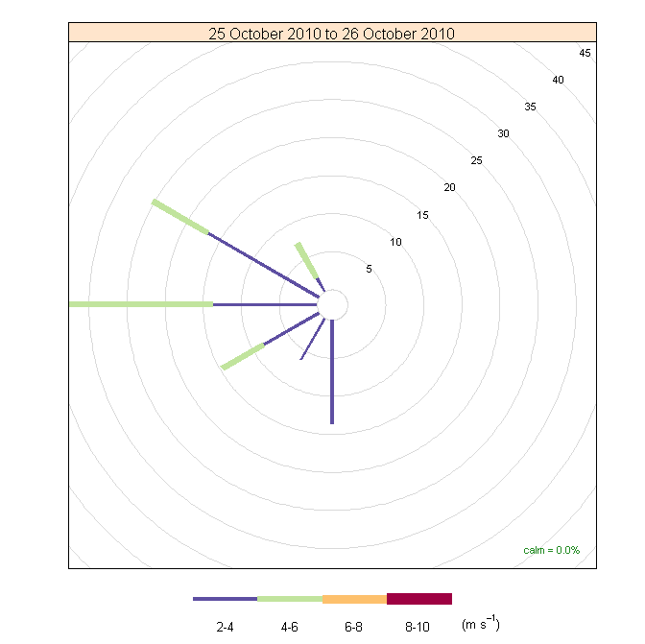

Episode Wind Range 14:00 to 15:30

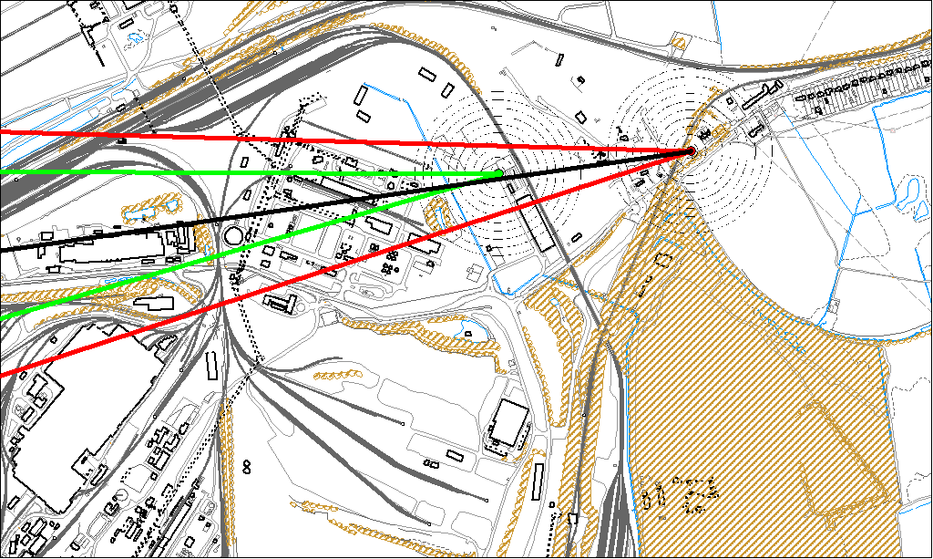

Potential Sources
The above map shows the Low Santon TEOM (indicated by the red lines) and the DLCO Osiris (indicated by the green). The black line within the red shows the wind direction of the highest concentration recorded during the 1 hour and 30 min period of focus.

As the Low Santon TEOM measured consistently higher concentrations during this period, it is likely that the TEOM was affected by a different source to the DLCO Osiris. Because of this difference the areas in which the red and green lines intersect are unlikely to be the location of the problem.

The likely areas include;

- Tarmac

The black line indicates the highest measured concentration of 207μg/m³ recorded at the Low Santon TEOM during this period. It runs through the Tarmac site.

Osiris Spike 20:30 & 21:00

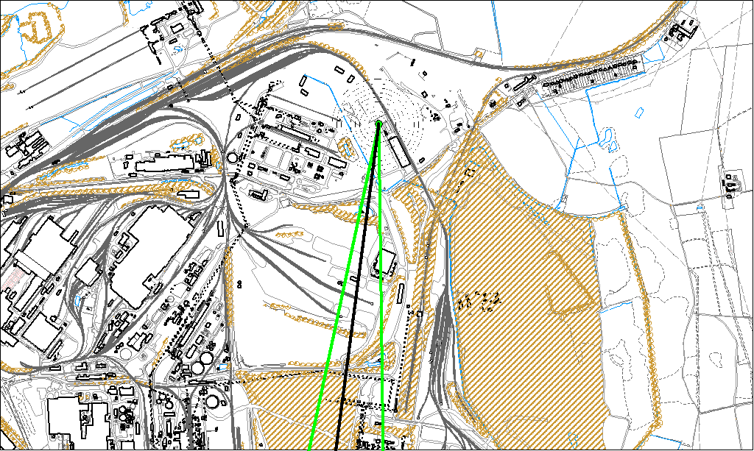

The DLCO Osiris measured a sharp increase in concentrations after 20:30 for approximately 30 minutes. This was by far the highest concentration at the Osiris for the day. The wind range indicates that the elevated concentration is likely to of originated from;

- The Redbourn Site
- Intermediate Site
- Ore Beds

If activities during this small window could be investigated at these sites it might help to identify a process likely to cause an increase in particulate levels.

